**First, a flood forced a B.C. couple from their home. Then came the looting**

 

***By***[**Jesse Ferreras**](https://globalnews.ca/author/jesse-ferreras/)**&**[**John Hua**](https://globalnews.ca/author/john-hua/)**Global News**

Posted May 15, 2018 9:42 pm

 Updated May 16, 2018 8:29 pm

Video will begin after these messages...

close video

A Midway, B.C. couple forced out of their home during the flooding returned home to find they'd been victimized by looters. John Hua reports – May 15, 2018

* [Leave A Comment](https://globalnews.ca/news/4211517/midway-bc-flood-looting/)
* [Share This Item On Facebook](https://www.facebook.com/sharer/sharer.php?u=https%3A%2F%2Fglobalnews%2Eca%2Fnews%2F4211517%2Fmidway-bc-flood-looting%2F)
* [Share This Item On Twitter](https://twitter.com/intent/tweet?text=First%2C%20a%20flood%20forced%20a%20B.C.%20couple%20from%20their%20home.%20Then%20came%20the%20looting%20-%20BC%20%7C%20Globalnews.ca%20https%3A%2F%2Fglobalnews%2Eca%2Fnews%2F4211517%2Fmidway-bc-flood-looting%2F)
* [Send This Page To Someone Via Email](mailto:?Subject=First%2C%20a%20flood%20forced%20a%20B.C.%20couple%20from%20their%20home.%20Then%20came%20the%20looting%20-%20BC%20%7C%20Globalnews.ca&body=%0D%0AFirst%2C%20a%20flood%20forced%20a%20B.C.%20couple%20from%20their%20home.%20Then%20came%20the%20looting%20-%20BC%20%7C%20Globalnews.ca%0D%0Ahttps%3A%2F%2Fglobalnews%2Eca%2Fnews%2F4211517%2Fmidway-bc-flood-looting%2F%0D%0A%0D%0A%0D%0A)
* [Share This Item](https://globalnews.ca/news/4211517/midway-bc-flood-looting/)

Descrease article font size

**-A**

Increase article font size

**A+**

First, flooding forced a couple from Midway, B.C. out of their home.

They spent two days in a hotel. Then they wanted to check and see how their house was holding up.

What they found shocked them — and left them wondering how anyone could lack compassion at a time when people are “down and out already.”

**Coverage of B.C. floods on Globalnews.ca:**

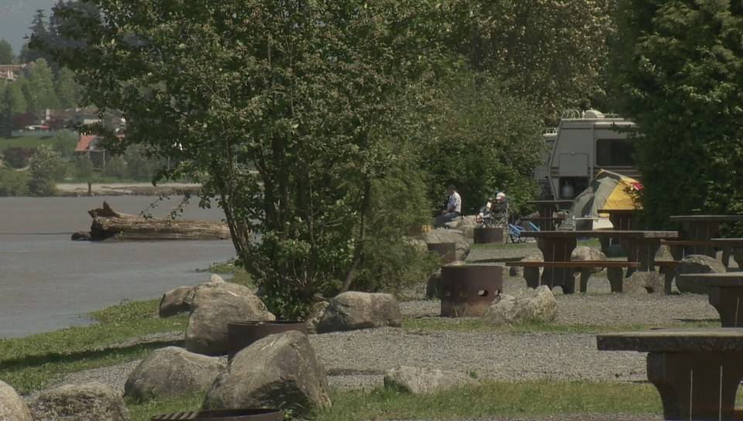2:04**B.C. flood crisis reaches Metro Vancouver**

[[](https://globalnews.ca/video/4211461/b-c-flood-crisis-reaches-metro-vancouver/)](https://globalnews.ca/video/4211461/b-c-flood-crisis-reaches-metro-vancouver/" \o "B.C. flood crisis reaches Metro Vancouver)

**[B.C. flood crisis reaches Metro Vancouver](https://globalnews.ca/video/4211461/b-c-flood-crisis-reaches-metro-vancouver/" \o "B.C. flood crisis reaches Metro Vancouver)**

[[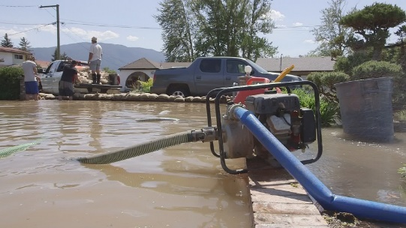](https://globalnews.ca/video/4208531/frustration-in-merritt-over-lack-of-flood-warning/)](https://globalnews.ca/video/4208531/frustration-in-merritt-over-lack-of-flood-warning/" \o "Frustration in Merritt over lack of flood warning)

**[Frustration in Merritt over lack of flood warning](https://globalnews.ca/video/4208531/frustration-in-merritt-over-lack-of-flood-warning/" \o "Frustration in Merritt over lack of flood warning)**

[[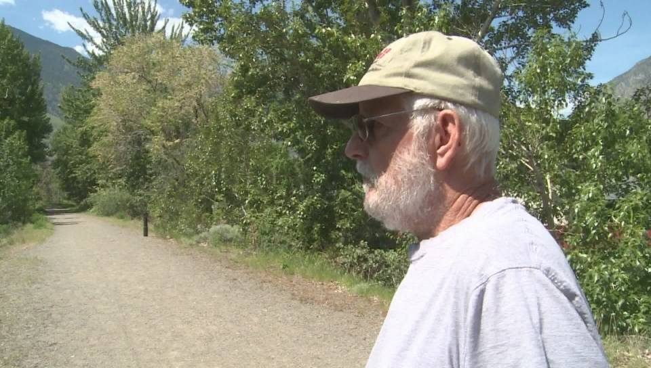](https://globalnews.ca/video/4208520/b-c-flood-watch-many-communities-on-evacuation-alert/)](https://globalnews.ca/video/4208520/b-c-flood-watch-many-communities-on-evacuation-alert/" \o "B.C. Flood watch: Many communities on evacuation alert)

**[B.C. Flood watch: Many communities on evacuation alert](https://globalnews.ca/video/4208520/b-c-flood-watch-many-communities-on-evacuation-alert/" \o "B.C. Flood watch: Many communities on evacuation alert)**

[[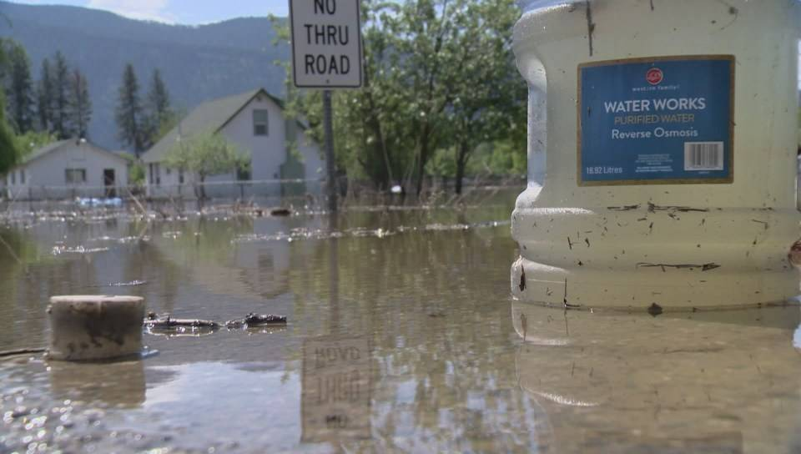](https://globalnews.ca/video/4208492/b-c-flood-watch-communities-brace-for-more-high-water/)](https://globalnews.ca/video/4208492/b-c-flood-watch-communities-brace-for-more-high-water/" \o "B.C. flood watch: Communities brace for more high water)

**[B.C. flood watch: Communities brace for more high water](https://globalnews.ca/video/4208492/b-c-flood-watch-communities-brace-for-more-high-water/" \o "B.C. flood watch: Communities brace for more high water)**

[[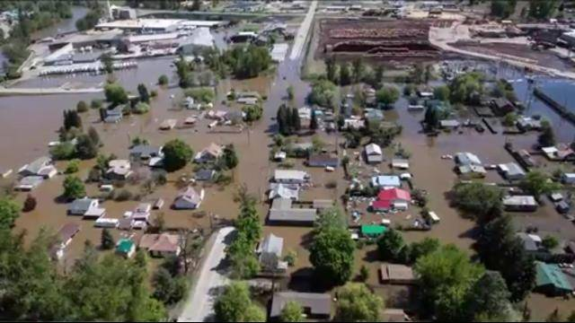](https://globalnews.ca/video/4208292/warmer-weather-has-bc-bracing-for-more-flooding/)](https://globalnews.ca/video/4208292/warmer-weather-has-bc-bracing-for-more-flooding/" \o "Warmer weather has BC bracing for more flooding)

**[Warmer weather has BC bracing for more flooding](https://globalnews.ca/video/4208292/warmer-weather-has-bc-bracing-for-more-flooding/" \o "Warmer weather has BC bracing for more flooding)**

Next Video

**STORY CONTINUES BELOW ADVERTISEMENT**

Midway is a community located between Grand Forks and Osoyoos, two communities that have seen [heavy flooding](https://globalnews.ca/news/4203522/b-c-flooding-2018-photos-videos/) this spring.

The Kettle River flows right through the community — and the water has jumped its banks.

An evacuation order was issued for Midway on May 10 — that’s when the Collins family went to a hotel.

**READ MORE:**[**B.C. flooding news Tuesday — Township of Langley issues evacuation alert amid rising water levels**](https://globalnews.ca/news/4210095/langley-township-evacuation-alert/)

When they returned to their home, they found that looters had taken several items.

That included a riding trailer and gas cans — they had hoped to use the latter with a pump that someone had lent them for their flooded basement.

**“I can’t believe somebody would do that to someone that’s down and out already and they’re upset about everything that’s going on in their homes,” Carol Collins told Global News.**

[**TWEET THIS**](https://twitter.com/intent/tweet?text=%22I+can%27t+believe+somebody+would+do+that+to+someone+that%27s+down+and+out+already+and+they%27re+upset+about+everything+that%27s+going+on+in+their+homes%2C%22+Carol+Collins+told+Global+News.%0A%0AFirst%2C+a+flood+forced+a+B.C.+couple+from+their+home.+Then+came+the+looting%0Ahttps://globalnews.ca/news/4211517/midway-bc-flood-looting/)

“That we don’t have a little compassion and lay off people’s property.

“We’re really upset about that, because I think that’s in the back of everyone’s mind — I’m staying here until the bitter end because we don’t want things disappearing and we can’t take them with us.”

**STORY CONTINUES BELOW ADVERTISEMENT**

The Collins family is reluctant to leave their home, despite the evacuation order.

They said they won’t leave their personal belongings on higher ground, but lock them in a shed and risk damaging them instead of having them stolen.

© 2018 Global News, a division of Corus Entertainment Inc.

https://globalnews.ca/news/4211517/midway-bc-flood-looting/